Configure Franklin Pierce University VPN Client
- Open the FortiClient VPN Client application installed on your computer
- Click the “Hamburger Button” to open the drop-down menu
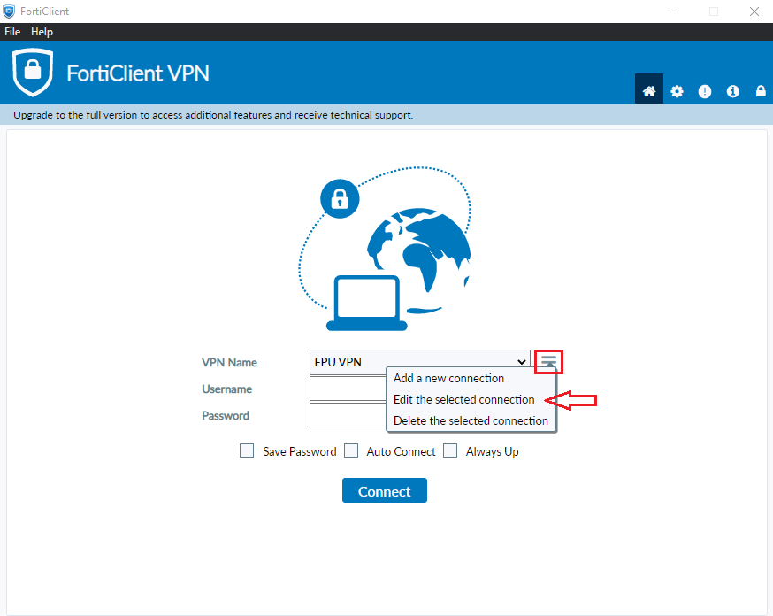
- Check ‘Enable Single Sign On (SSO) for VPN Tunnel’
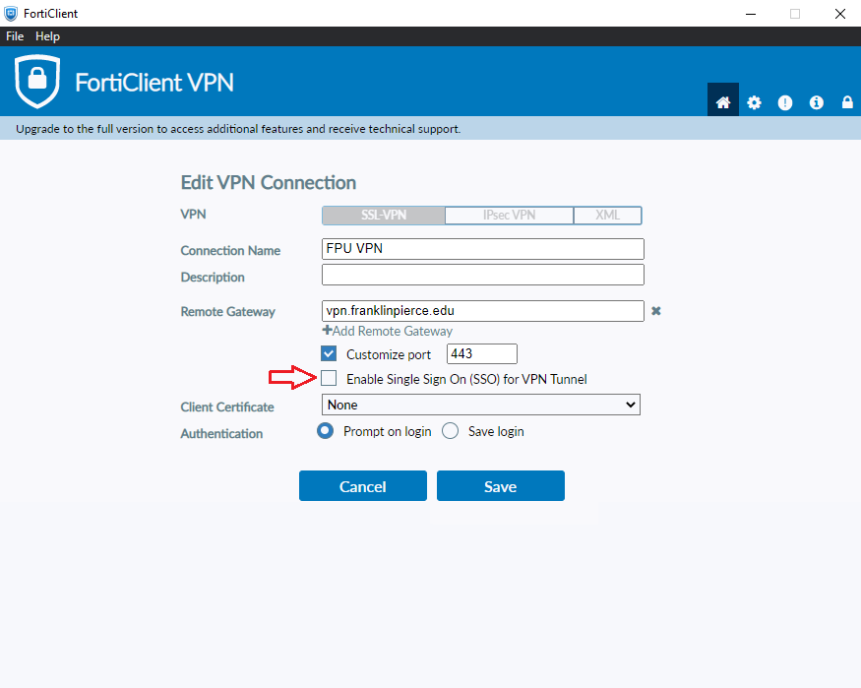

- Click ‘Save’
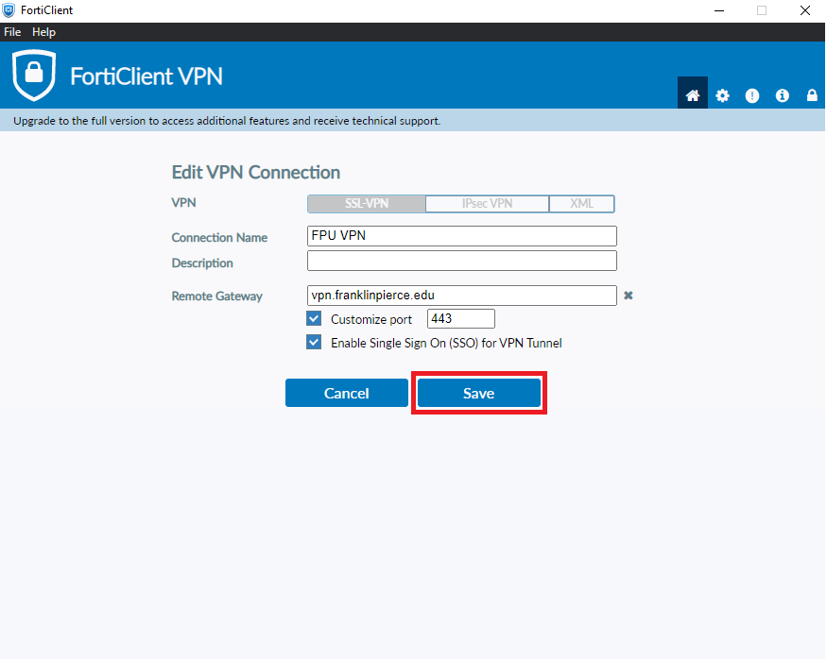
- The VPN Client is now configured, click ‘SAML Login’ to be prompted by Microsoft authentication for your FPU Email and Password
